Ce se va afisa in urma executiei programului de mai jos?

public class Outer {  
 public String getValue(){  
 return "Outer";  
 }  
 public class Inner1{  
 public String getValue(){  
 return "Inner1";  
 }

}  
 public static class Inner2{  
 public String getValue(){  
 return "Inner2";  
 }  
 }  
 protected class Inner3{  
 public String getValue(){  
 return "Inner3";  
 }  
 }

private class Inner4{  
 public String getValue(){  
 return "Inner4";  
 }  
 }

}

class Tester{  
 public static void main(String[] args) {  
 Outer outer=new Outer();  
 Outer.Inner1 inner1 =outer.new Inner1();  
 Outer.Inner2 inner2=outer.new Inner2();  
 Outer.Inner3 inner3=outer.new Inner3();  
 Outer.Inner4 inner4=outer.new Inner4();  
 String output=new String("");  
 output+=outer.getValue();  
 output+=inner1.getValue();  
 output+=inner2.getValue();  
 output+=inner3.getValue();  
 output+=inner4.getValue();  
 System.out.println(output);

}  
 }

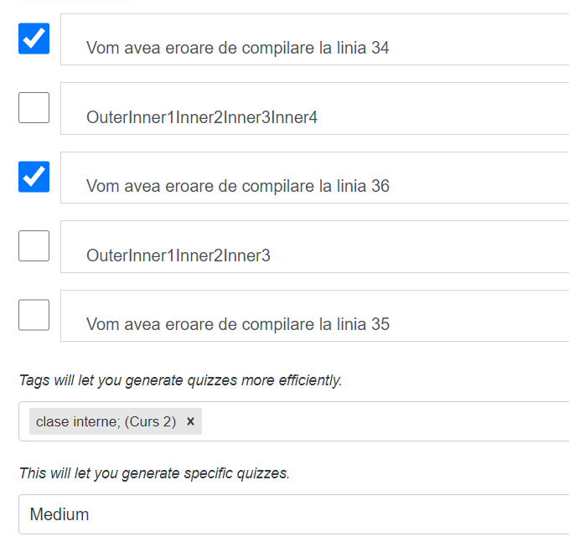

si explicatia :

Vom avea eroare de compilare la linia 34 . Linia "Outer.Inner2 inner2=outer.new Inner2();" este incorecta deoarece clasa Inner2 este o clasa statica (deci nu are nevoie de un obiect de tip Outer pentru a fi instantiata.

De asemenea vom avea eroare de compilare la linia 36. Linia "Outer.Inner4 inner4=outer.new Inner4();" deoarece clasa Inner4 este declarata private in interiorul clasei Outer.